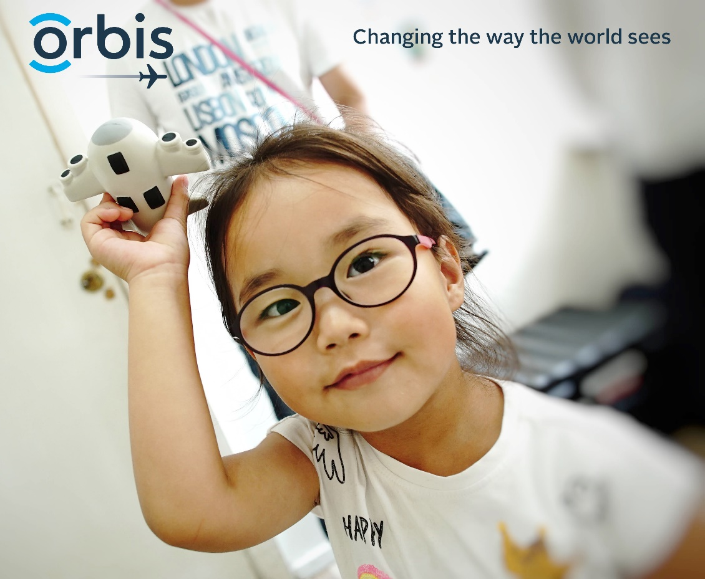

Dear FIRST NAME,

Thank you so much for supporting my fundraising event on DATE at LOCATION for Orbis Canada! With your generous contribution, we were able to raise $XX,XXX to help in the fight against avoidable blindness. The money raised at EVENT NAME will contribute to saving the sight of hundreds of children, parents and grandparents.

For every $100 we raised at EVENT NAME, we can save the sight of a child, creating a life of endless possibility. Thanks to your participation, Orbis can continue to mentor, train and inspire local eyecare teams to fight blindness in their own communities for generations to come. If you would like to learn more about Orbis’s sight saving work, you can visit can.orbis.org.

Once again, thank you for helping me support Orbis Canada. Together, we are ending avoidable blindness around the world, one child at a time!

Warm Regards,

YOUR NAME

